Practicum No.9 Date:15/10/2026
Reasoning with Forward and Backward Chaining

- Practical Significance (with respect to practicum no. 1)
Forward and backward chaining are inference mechanisms used in rule-based AI systems to derive new knowledge from existing facts. These methods form the core reasoning strategy behind expert systems and decision support tools in diagnostics, automation, and recommendation systems.
Industry-Relevant Job Positions:
- Expert System Developer
- AI Reasoning Engineer
- Decision Support System Designer
- Knowledge-Based System Analyst
- Competency and Industry-Specific Practical Skills (Kindly copy from the Course Structure)
This practicum exercise is expected to develop the following skills for the industry-identified competency.
- Use the principles of artificial intelligence to solve complex engineering problems.

(copy 2 to 4 skills from the above industry-specific skills)
- Apply logical reasoning and knowledge representation methods for building rule-based systems and intelligent agents. (Cognitive Domain)
- Formulate AI-based solutions to real-world problems using appropriate AI techniques. (Cognitive Domain)
- Interpret AI model outcomes and ensure explainability in decision-making systems. (Cognitive Domain)
- Adopt ethical principles and responsible practices in the development and deployment of AI systems. (Affective Domain)
- Relevant CO(s) (Kindly copy from the Course Structure)
CO4. Develop probabilistic and rule-based systems reasoning models for uncertain AI scenarios.

- Practical Outcome (PrO) (Kindly copy from the Course Structure)
- Develop Forward and Backward Chaining method for the given rule-based reasoning problem .

- Related ADO(s) (Kindly copy from the Course Structure)
- Follow ethical practices in AI model development and deployment.
- Follow adaptability to emerging AI techniques and technologies.
- Follow a structured approach to AI driven decision making.
- Follow a commitment to continuous learning.

- Minimum Underpinning Theory (Theory should be written only to relate this practicum)
Forward and Backward Chaining are two core reasoning methods used in rule-based expert systems to draw conclusions from known facts and inference rules.
Forward Chaining is data-driven reasoning, where known facts are applied to rules to infer new facts. It proceeds from known facts → conclusions and is ideal for diagnostics and situation assessment.
Backward Chaining is goal-driven reasoning, which starts with a goal and works backwards to determine if it can be derived from the known facts using available rules. It is commonly used in systems like Prolog and decision support applications.
In propositional logic terms:
Facts are atomic assertions (e.g., human(Socrates))
Rules are implications (e.g., IF human(x) THEN mortal(x))
Inference uses substitution and unification techniques to match facts with rule premises
- Practicum Set-up/Circuit Diagram/Algorithm/Flowchart (Copy and paste the probable set-up of the machines)

Algorithm:
Step 1: Initialize the set of known facts.
Step 2: For each rule in the knowledge base:
a. Extract the rule's premise and conclusion.
b. Check each fact in the known facts.
c. If the fact matches the pattern of the premise (e.g., human(x)),
substitute the variable with the constant in the fact.
d. Use substitution in the conclusion to infer a new fact.
Step 3: Add the inferred fact to the set of inferred facts.
Step 4: Repeat the process until no new facts are inferred.
Step 5: Return the complete set of inferred facts.
Python Sample Code:
Example: Simulate basic forward and backward chaining.
facts = ["human(Socrates)"]
rules = [("human(x)", "mortal(x)")]

def forward_chaining(facts, rules):
inferred = set(facts)
for premise, conclusion in rules:
for fact in facts:
if fact.startswith(premise.split('(')[0]):
var = fact.split('(')[1][:-1]
new_fact = conclusion.replace('x', var)
inferred.add(new_fact)
return inferred

inferred_facts = forward_chaining(facts, rules)
print("Inferred Facts:", inferred_facts)
- Resources Required

S. No. | Name of Resource | Suggested Broad Specification | Quantity
- 1 | Computer System | Intel i5 or higher, 8 GB RAM, 256 GB SSD, Python 3.x installed | 1 per student
- 2 | Python Programming Environment | Python 3.x with standard libraries (NumPy, time module) | Installed
- 3 | Jupyter Notebook or IDE (e.g., VSCode, PyCharm) | For writing and running Python code | 1 per student

- Safety Precautions
- Avoid sharing login credentials.
- Ensure antivirus software and firewalls are updated.
- Keep eatables away from computers.
- Follow Institutional laboratory policies.
- Avoid storing confidential data in lab computers.

- Procedure
- Interpret the flowchart in Section VII to understand the difference between forward and backward chaining as reasoning strategies in rule-based systems.•
- Define a knowledge base using propositional rules (e.g., IF–THEN statements) and known facts.
- Represent rules and facts using dictionaries, lists, or logical expressions in Python.
For forward chaining, implement a function that matches known facts with rule premises and derives new conclusions until no further inference is possible.
For backward chaining, implement a function that attempts to prove a goal by recursively verifying whether it can be inferred from known rules and facts.
- Use Boolean logic or pattern matching to compare known facts and rule antecedents.
- Execute both chaining methods on a sample knowledge base (e.g., medical diagnosis, academic eligibility, simple automation).
- Print the inference steps showing which rules fired and what conclusions were derived.
- Validate whether both chaining approaches yield consistent and correct results for the same goal or query.
- Analyze the strengths and weaknesses of forward vs backward chaining in your application context.
- Document the rules, facts, code, outputs, and inference steps clearly in a structured report.
- Submit the working implementation, logic explanation, and report for evaluation.
- Actual Resources Used (To be filled by the students)

S. No | Name of Resource | Broad Specifications |  | Quantity | Remarks (If any)
S. No | Name of Resource | Make | Details | Quantity | Remarks (If any)
- 1 | Operating System | Microsoft | Windows 11 | 1
- 2 | Programming Language | SWI-Prolog | Prolog logic programming language | 1 | -
- 3 | Software Development Kit | SWI-Prolog | SWI-Prolog interpreter and development environment | 1 | -
- 4 | Libraries | Built-in Prolog | Standard predicates and logical operators | 1 | -
- 5 | Graphics/Animation tool | Not used | - | 0 | -
- 6 | Front-end tool | Not used | - | 0 | -
- 7 | Back-end tool | SWI-Prolog | Executes facts, rules, and unification queries | 1 | -
- 8 | Virtual Lab | Not used | - | 0 | -
- 9 | Specific Hardware | Lenovo laptop | Computer system used to run SWI-Prolog | 1 | -
- 10 | Simulation/Emulation Tool | SWI-Prolog console | Tests aquarium facts, rules, and queries | 1 | -

- Actual Procedure Followed (To be filled by the students on the left page)

- Opened SWI-Prolog on the computer.
- Created a Prolog source file named prac9.pl.
- Entered the aquarium facts into the knowledge base.
- Defined rules for cooling, aeration, chiller activation, and air-pump activation.
- Defined rules to identify aquariums requiring attention and aquariums that are stable.
- Saved and consulted the Prolog program.
- Executed queries to test cooling and chiller activation.
- Tested aeration, air-pump activation, and attention rules.
- Checked aquarium stability using backward chaining.
- Executed the forward-chaining demonstration and recorded the results.

- Results/Obervations (To be filled by the students on the left page if space is not sufficient)

- The system identified that cooling and chiller activation were required because Aquarium A1 had a high water temperature.
- The system identified that aeration and air-pump activation were required because Aquarium A1 had low dissolved oxygen.
- The system concluded that Aquarium A1 required attention.
- The system verified that Aquarium A1 was stable according to the given pH, filter, and water-level facts.

- Results/Observations (To be filled by the students)
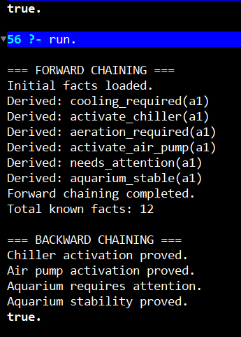
Tasks
- Represent the aquarium conditions as facts in SWI-Prolog.

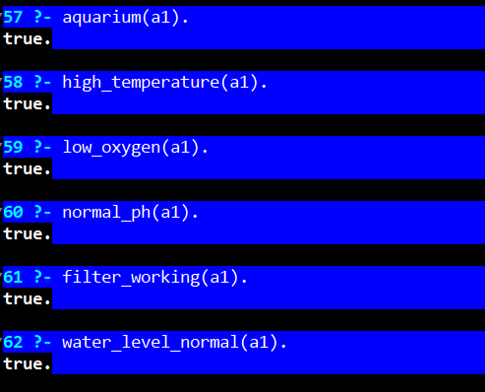
- Define rules for cooling, aeration, chiller activation, air-pump activation, and aquarium stability.

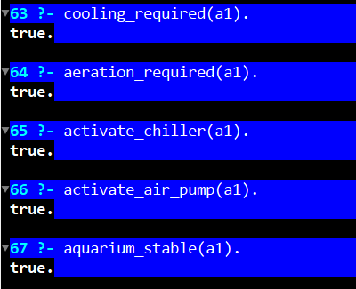
- Implement forward chaining to derive new conclusions from the initial facts.

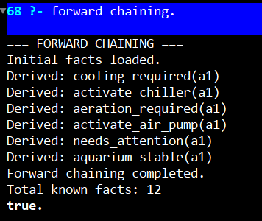
- Implement backward chaining to verify whether a specified goal can be proved.

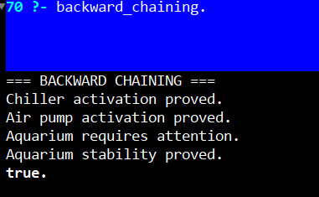
- Display the facts and conclusions derived during forward chaining.

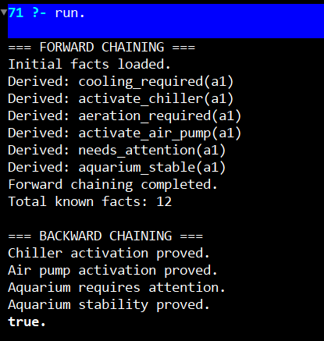
- Test whether the chiller should be activated.

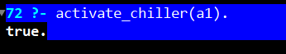
- Test whether the air pump should be activated.

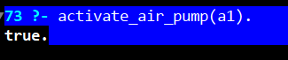
- Test whether the aquarium requires attention.


- Test whether the aquarium is stable.

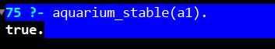
- Display the results and interpret the conclusions.

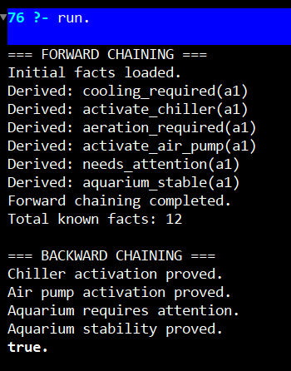

- Interpretation of Results (Students to state the meaning of the above-obtained results/observations)

The results demonstrate how forward and backward chaining support rule-based reasoning. Forward chaining derives conclusions from known facts using logical rules. Backward chaining begins with a goal and checks whether the facts and rules can prove it. The aquarium system identifies conditions requiring cooling and aeration while separately checking the conditions required for aquarium stability.

- Conclusions (Students to draw conclusions (or take decisions) based on the interpretation of results).

The Smart Aquarium Management System was implemented using SWI-Prolog facts and rules. The program demonstrated how logical inference can identify cooling requirements, aeration requirements, maintenance attention, and aquarium stability. Forward and backward chaining provide useful reasoning methods for developing rule-based intelligent systems.

- Suggested Practicum Related Questions:
Note: Below given are a few sample questions for reference. Teachers must design more such questions in order to ensure the achievement of pre-determined course outcome.
- What is the difference between forward chaining and backward chaining?
- In which scenarios would you prefer forward chaining over backward chaining, and vice versa?
- How are facts and rules represented in your inference engine?
- What is unification, and why is it important in rule-based reasoning?
- How does backward chaining implement goal-driven inference?
- How did your program substitute variables in rules with actual values from facts?
- What logic did you use to infer new facts in forward chaining?
- Can your implementation handle multiple rules firing in sequence?
- How did you manage duplicate or redundant inferences in your engine?
- How would you extend this system to support predicate logic or multi-step reasoning?
- What types of domains can benefit from chaining-based reasoning systems?
- What were the final inferred facts in your forward chaining execution?
- How would you verify if a goal is provable using backward chaining?
- What are the limitations of chaining methods in large or uncertain knowledge bases?
- How would you integrate your inference engine into an expert system?
- References / Suggestions for further reading
Online Tutorials & Articles
- GeeksforGeeks – Inference Engine in AI (Forward and Backward Chaining- https://www.geeksforgeeks.org/inference-engine-in-artificial-intelligence/

- TutorialsPoint – Rule-Based Systems
https://www.tutorialspoint.com/artificial_intelligence/artificial_intelligence_rule_based_systems.htm

Interactive Platforms for Practicing
- Try Python – Online Python Playground - https://trypython.org/
- Replit – Inference Engine Practice in Python - https://replit.com/
Video Lectures & Courses
- NPTEL – Artificial Intelligence: Knowledge Representation and Reasoning - https://onlinecourses.nptel.ac.in/noc23-cs88
- Forward and Backward Chaining - https://www.youtube.com/watch?v=9d0z-ZzFwog
- (HarvardX) – Knowledge-Based Agents- https://cs50.harvard.edu/ai/2020/
- Suggested Assessment Scheme
The given performance indicators should serve as a guideline for assessment regarding process and product-related marks.
Note: The weightage for the process-related skills and product-related skills will change depending upon the PrO, COs, and competency related to the concerned course.

Performance indicators |  | Max. Marks | Marks Obtained
Process related skills: 18 Marks - 60%
 | Understanding of forward and backward chaining concepts | 3
 | Accurate mapping of rules and facts in the inference engine | 6
 | Followed Coding Standards and Best Practices | 6
 | Logical structuring and flow of the inference mechanism in code | 3
Product related skills: 12 Marks - 40%
 | Correctness of inferred facts or conclusion path | 3
 | Ability to trace reasoning (rule firing/explanation steps shown clearly) | 3
 | Error Handling & Debugging | 1.5
 | Interpretation of Results and Conclusions | 1.5
 | Practical related questions | 1.5
 | Submitting the Report on time | 1.5
 | Total | 30

To be filled by Student:

S.No. | Name of the Student | Register No.
1 | SHREYA GEORGE | URK25CS1204

To be filled by the Faculty Member:
Marks Obtained |  |  | Name and Designation of the Faculty Member | Date of Evaluation
Process-Related Skills  (18) | Product-Related Skills (12) | Total  (30)

